Bahria University,

Karachi Campus



LAB EXPERIMENT NO.

**01**

LIST OF TASKS

|  |  |
| --- | --- |
| TASK NO | OBJECTIVE |
| 1 | **Write a Python program to calculate the roots of a quadratic equation of the form ax2 + bx + c = 0, where a, b, and c are coefficients provided by the user.** |
| 2 | **Write a Python program that calculates the factorial of a non-negative integer n provided by the user.** |
| 3 | **Write a python program to find the maximum and minimum number in the following array {12,56,34,2,56,98,6,54,6,54}** |
| 4 | **Write a Python program that checks whether a given positive integer n provided by the user is a prime number or not.** |
| 5 | **Write a python program that takes two matrix (2 by 2) from user, and perform addition, subtraction, multiplication, and division on them.** |

**Task 1: Write a Python program to calculate the roots of a quadratic equation of the form ax2 + bx + c = 0, where a, b, and c are coefficients provided by the user.**

**Solution:**

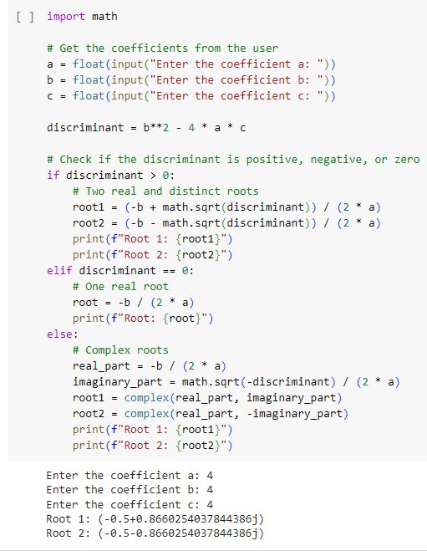

**Task 2: Write a Python program that calculates the factorial of a non-negative integer n provided by the user.**

**Solution**

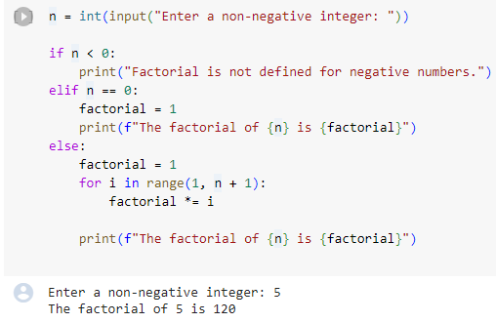

**Task 3: Write a python program to find the maximum and minimum number in the following array {12,56,34,2,56,98,6,54,6,54}**

**Solution**

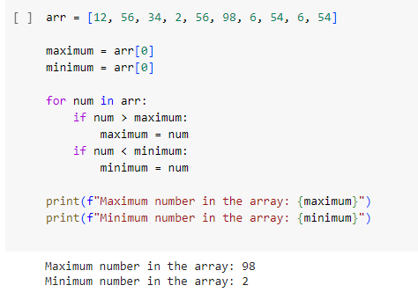

**Task 4: Write a Python program that checks whether a given positive integer n provided by the user is a prime number or not.**

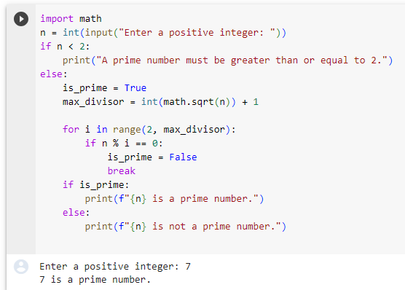

**Task 5: Write a python program that takes two matrix (2 by 2) from user, and perform addition, subtraction, multiplication, and division on them.**

**Solution:**

def read_matrix(prompt):

    print(prompt)

    matrix = []

    for i in range(2):

        row = []

        for j in range(2):

            element = float(input(f"Enter element for row {i + 1}, column {j + 1}: "))

            row.append(element)

        matrix.append(row)

    return matrix

# Read two matrices from the user, element by element

matrix1 = read_matrix("Enter the first 2x2 matrix:")

matrix2 = read_matrix("Enter the second 2x2 matrix")

# Perform operations

print("Matrix Addition:")

result = add_matrices(matrix1, matrix2)

for row in result:

    print(row)

print("Matrix Subtraction:")

result = subtract_matrices(matrix1, matrix2)

for row in result:

    print(row)

print("Matrix Multiplication:")

result = multiply_matrices(matrix1, matrix2)

for row in result:

    print(row)

print("Matrix Division:")

result = divide_matrices(matrix1, matrix2)

if result is not None:

    for row in result:

        print(row)

